Arduino Lab Setup

Arduino Board Pins

* Pin 2 – Valve
* Pin 4 – Pump
* Pin 7 – Ignitor
* Pin 8 – Level sensor low
* Pin 10 – SD card
* Pin 13 – Level sensor high
* Analog 0-4 – Thermistors 1-5
* Analog 5 – Level sensor 4-20 mA
* 3.3V – Red line goes to power line on breadboard
* Ground – Black line goes to ground line on breadboard
* AREF – Red to positive line on breadboard (analog positive line)

Breadboard Connections

Thermistors

* One end of each goes to ground line (here connected to black wire)
* Other end goes in series of red wire – resistor – analog input wire
* Other end of resistor goes to power line
* Thermistor 1: Red C5, Resistor B5-Power 2, Analog A5-A0
* Thermistor 2: Red E8, Resistor C8-Power 7, Analog A8-A1
* Thermistor 3: Red C11, Resistor B11-Power 10, Analog A11-A2
* Thermistor 4: Red E14, Resistor C14-Power 12, Analog A14-A3
* Thermistor 5: Red C17, Resistor B17-Power 15, Analog A17-A4

Pump

* Pump relay signal – Pin 4
* Pump relay ground – Ground 6
* Pump relay power – Power 1

Level Sensor – Sends signal when below low and above high/analog 4-20 mA output

* Depth positive (red) – To power supply
* Depth negative (black) – To power supply
* Depth relay common (brown) – 0+13
* Depth relay high (purple) – Pin 8
* Depth relay low (yellow) – Pin 13
  + Or
* Negative line from sensor to B23, 100 Ω resistor C23 to D21, Negative power E21
  + Analog wire A21-A5

Ignitor/Value

* Ignitor Signal – Pin 7
  + Facing issue with small current flowing through Pin 7, temporary set up
  + Pin 7 to A26 – Resistor C26 to C29 – Signal E26 to Board – Wire E29 to Ground 30
* Valve Signal – Pin 2
* Positive – Power 25
* Ground – Ground 23

Arduino commands

* Valve – output
* Ignitor – output
* Pump – output
* MinDepth & MaxDepth – input

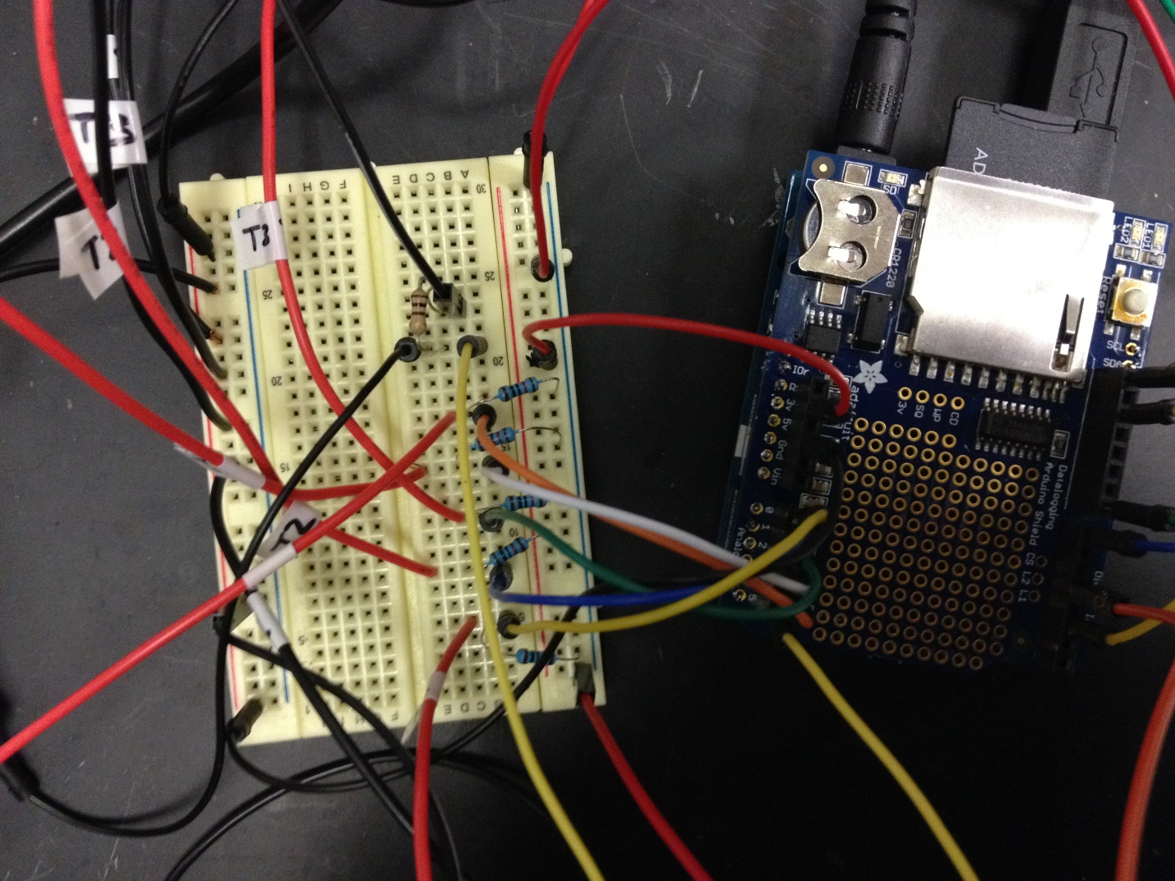

5 thermistors, Red to 10K resistor

5 thermistors, Black to ground

Ground

AREF

Level power

Level sensor

3.3V

**Material Specs**

Arduino Uno

* Input: 7-12VDC
* Operating voltage: 5VDC
* DC Current per I/O Pin: 40mA
* DC Current for 3.3V Pin: 50mA

Relay

* 2 Channel [5V Relay Shield](http://www.amazon.com/SunFounder-Channel-Shield-Arduino-Raspberry/dp/B00E0NTPP4/ref=sr_1_1?ie=UTF8&qid=1428688519&sr=8-1&keywords=arduino+relay) module for Arduino

Gas valve – CWX-15Q, CR-02

* (Size?) NPT threads, Max pressure 1 MPa, Max temp 100 °C
* Input: DC 12V, Max 167 mA (Max 2W)
* Available from: [Alibaba](http://www.alibaba.com/product-detail/CWX-15Q-series-3-4-SS304_1809778717.html)
* $15
* Three wire: Red-power, Blue-ground, Yellow-signal

Ignitor – Grill Pro Universal Electronic Ignitor Kit (20620), Model SD-E5

* Input: DC 1.5V, 280-320 mA (0.42-0.48 W)
* Output: 10 kV
* Available from: Grillpro.com or [Amazon](http://www.amazon.com/GrillPro-20620-Electric-Button-Igniter/dp/B000FJVKNM)
* $25

Level Sensor

* Input: DC 24V (or 12V), 2 mA (0.5 W consumption); 400Ω max loop resistance
* The 4-20 mA output can be used to provide the proportional level of liquid in any tank or vessel. The 4 relays can be used to control multiple combinations of pumps, valves and/or alarms. The signal can be connected to any device that accepts a loop powered 4-20 mA signal or relay output, such as a PLC, SCADA, DCS, display, controller, etc
* Output: 4-20 mA (when loop powered)
* Range: 5-125 cm (2-49”)
* Accuracy: 3 mm
* Temp range -7-60 °C (31-140 °F), Max pressure 30 psi
* 1” NPT thread
* The red and black wires can be extended up to 1,000 feet using a 22 gauge or larger wire, however do not extend the green and white wires
* Available from:
* $$

Pump – SeaLand TW-Series (T12) Macerator Pump

* Input: DC 12V, 6 A (48 W)
* Flow: 1136 L/hr
* Lift: 3 m (10 ft)
* Fittings: 1 – 1 ½”, not threaded, use rubber reducing bush to adapt to PVC
* Available from: [Amazon](http://www.amazon.com/SeaLand-Sanipump-Discharge-Macerator-Whisper/dp/B000XBH2D4/ref=sr_1_sc_1?ie=UTF8&qid=1422551946&sr=8-1-spell&keywords=seland+waste+discharge+pump)
* $300

Valve wiring diagram:

